Lab 1: Sniffing and Spoofing
Instructions:
Accomplish Set 1, Tasks 1, 2, and 4. Include all necessary screenshots (cause and effect) for each task).

Starting Information:
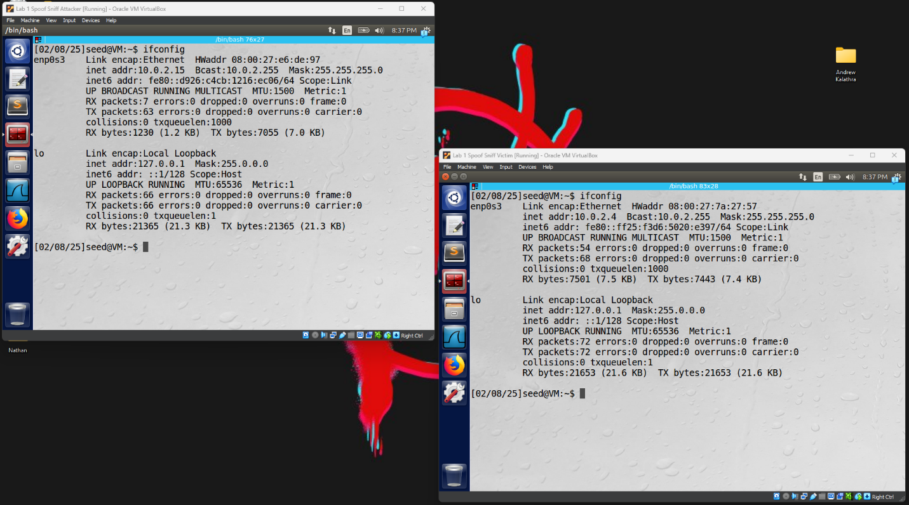
- This is the attacker and victim’s IP.

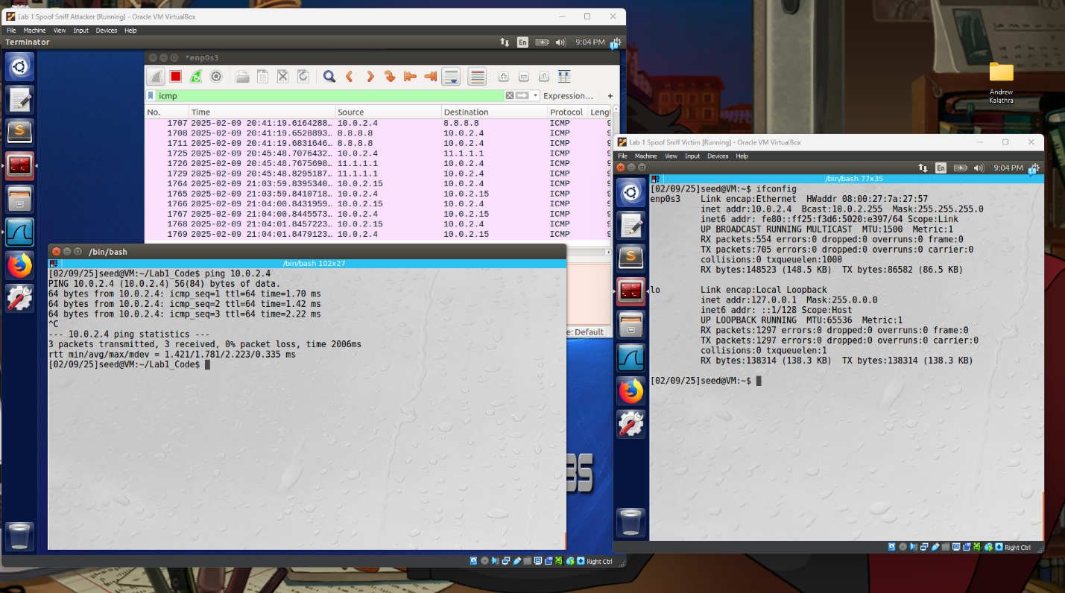
- This is a successful ping.

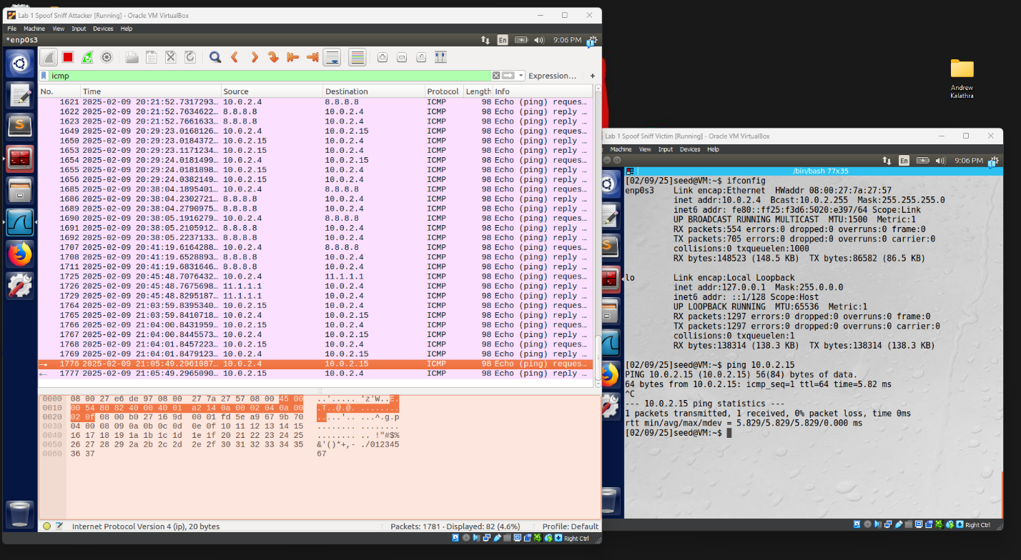
- This is a successful sniff using Wireshark.

Task 1: Sniffing Packets

- 1.A Trying to sniff using root privileges (sudo) and without root privileges.
  - 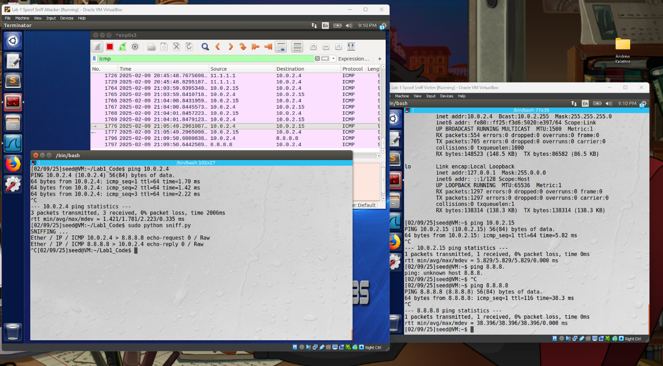
  - This shows three (double) packets that were successfully sniffed by the attacker. The packets were ICMP requests from the victim and replies from the attacker.

  - 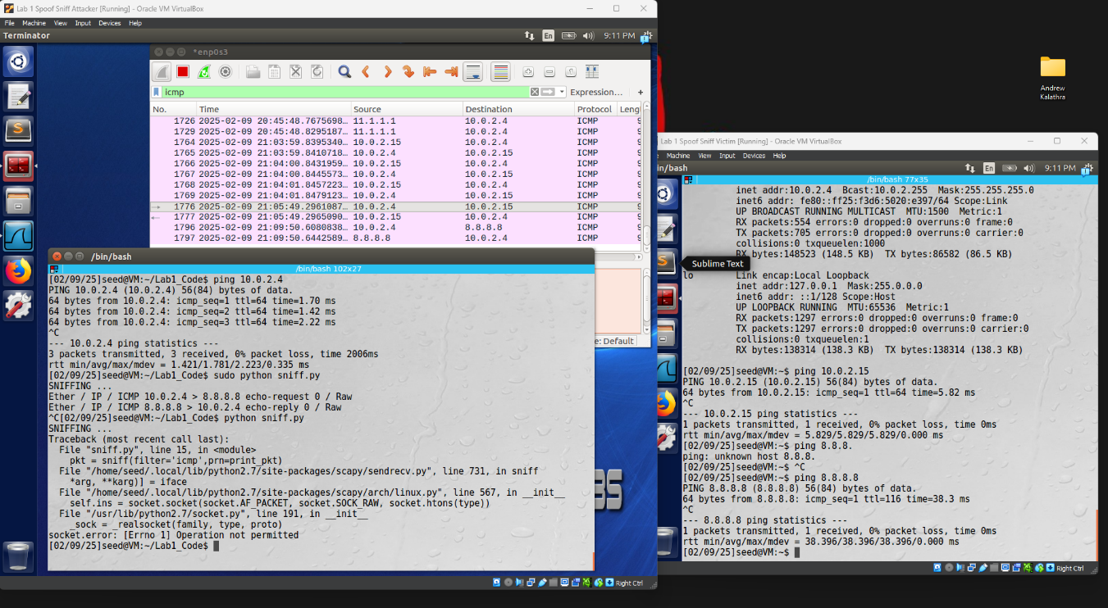
  - This shows the failure to run the code due to root privileges needed to run socket.

- 1.B
  - Capture only ICMP packets.
    - 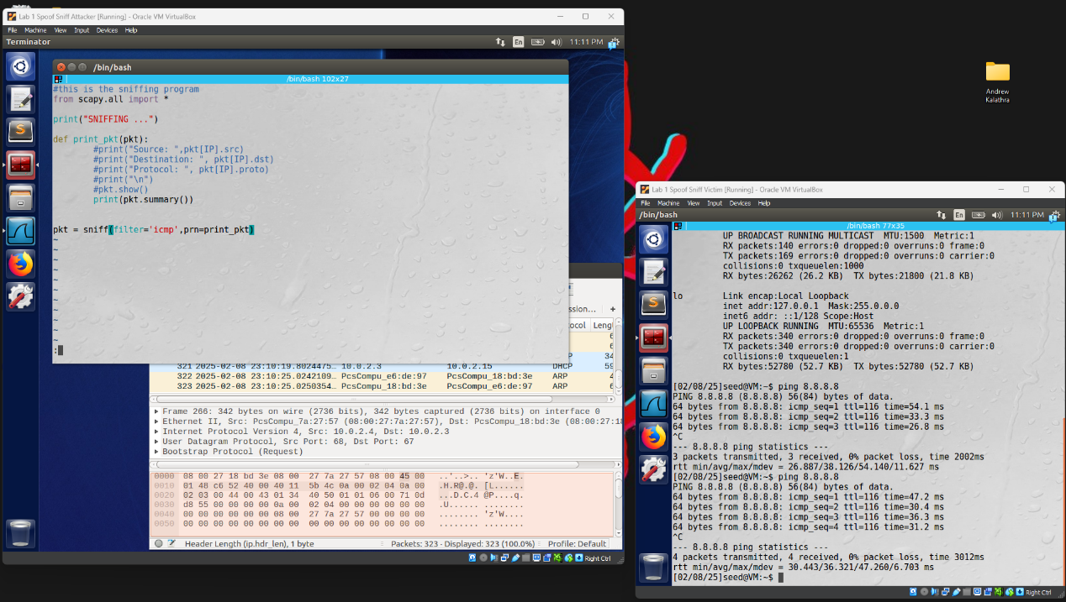
    - In this, we can see that the filter is set to ICMP, to only sniff ICMP packets. It is important to note that I will be using the .summary() method instead of those commented out. This is because they caused more errors than anything, and the summary was useful.
    - 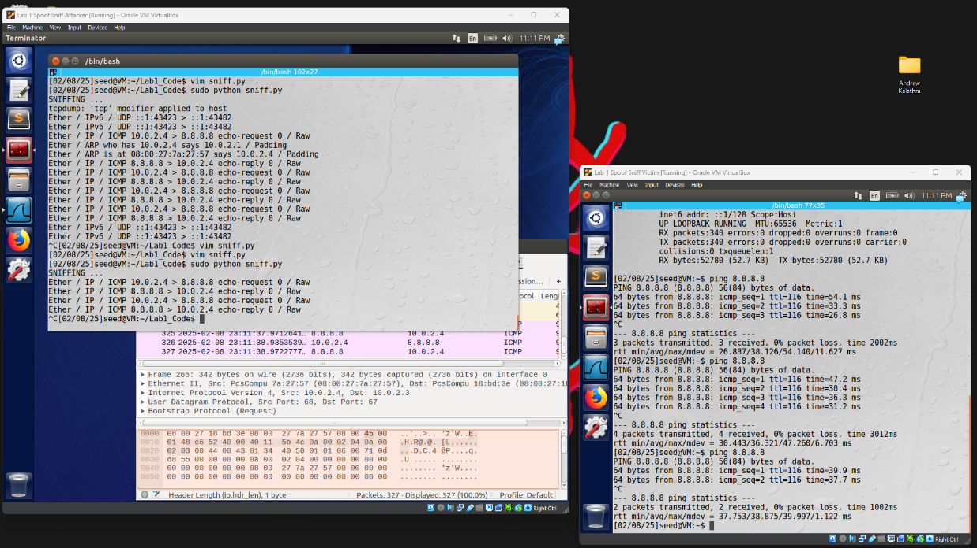
    - In this image, we can see that the victim (right) pings 8.8.8.8. A ping is an echo request, which is a type of ICMP packet. The attacker (left) accurately sniffs the sent and received ICMP packets, 4 in total.

  - Capture any TCP packets that comes from a particular IP and with a destination port number 23.
    - 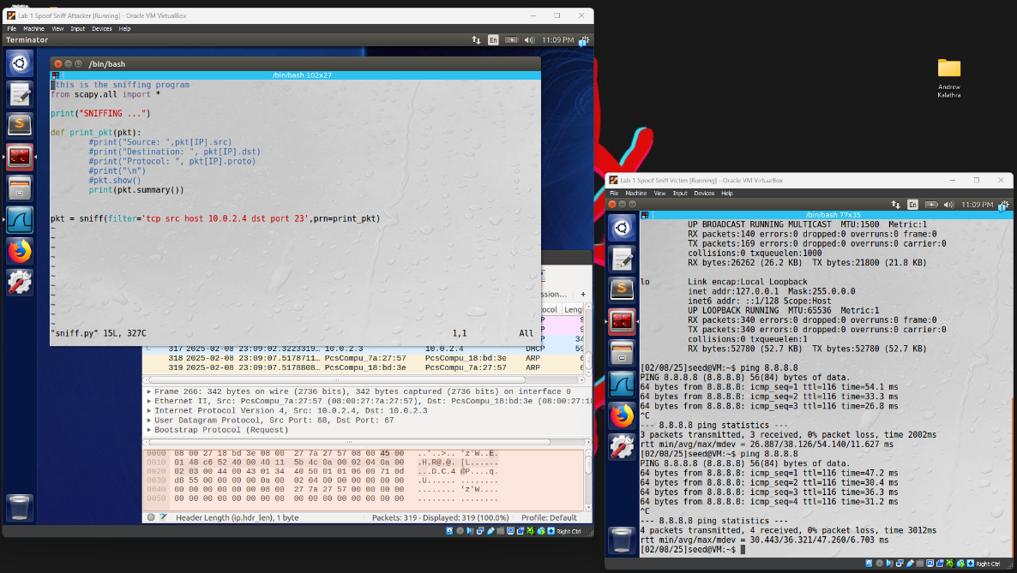
    - In this image, we can see that the filter is reset to capture TCP packets with a source address of 10.0.2.4 (which is conveniently the victim’s address) and with a destination port of 23.
    - 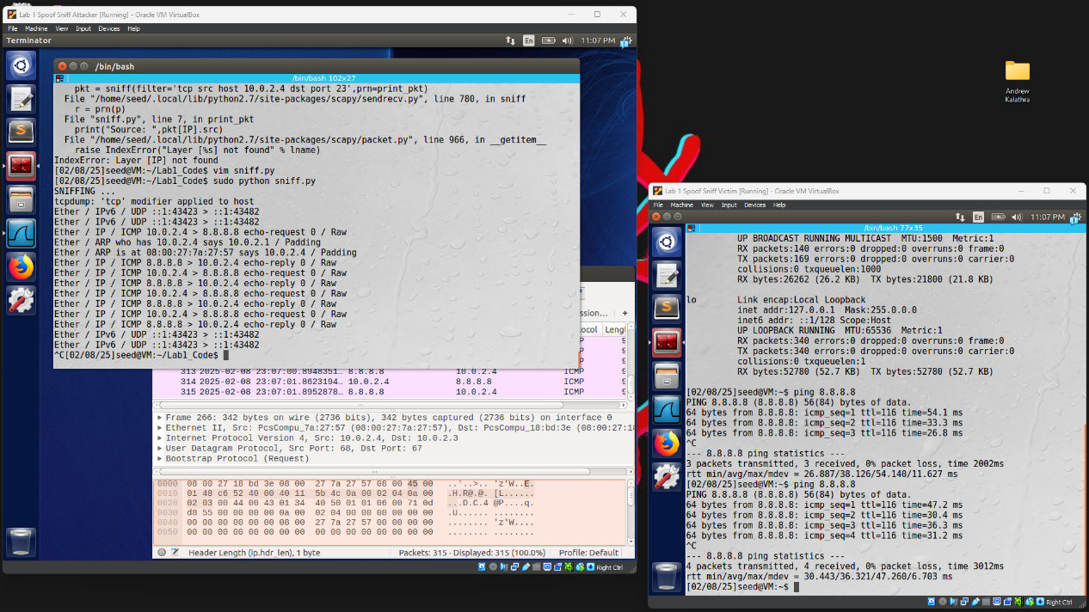
    - In this image, we can see that the victim (who’s address is the source address in the attacker’s filter) sends out four ping’s to 8.8.8.8. Port 23 is the telnet port, and the attacker isolates just these packets from the victim.

  - Capture packets coming from or going to a particular subnet. You can pick any subnet, such as 128.230.0.0/6; you should not pick the subnet that your VM is attached to.
    - 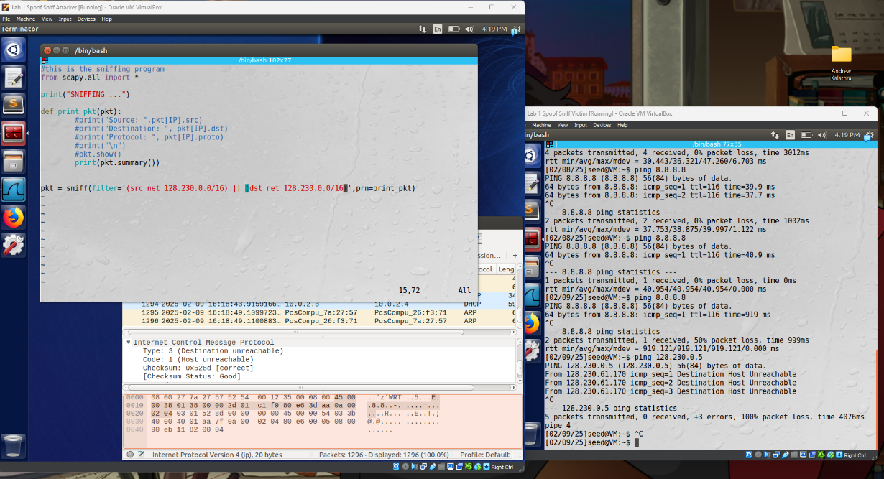
    - In this image, we can see that the filter is reset to capture packets either going to or coming from the subnet 128.230.0.0/16 (sticking directly to the instructions).
    - 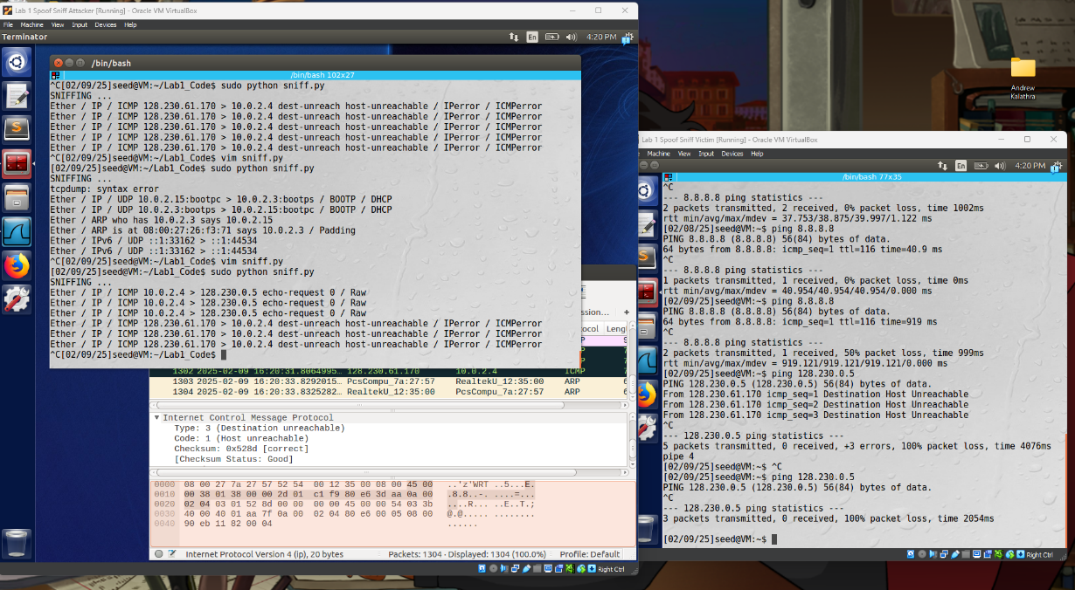
    - In this image, we can see that the victim pinged 128.230.0.5. Three packets were transmitted, but none were received, meaning that there was no echo reply. The attacker was able to see this with three echo requests to the 128.230.0.5 address as the destination, and the router for that subnet (128.230.61.170) replied with an ICMP packet stating that address was unreachable.

Task 2: Spoofing ICMP Packets
- 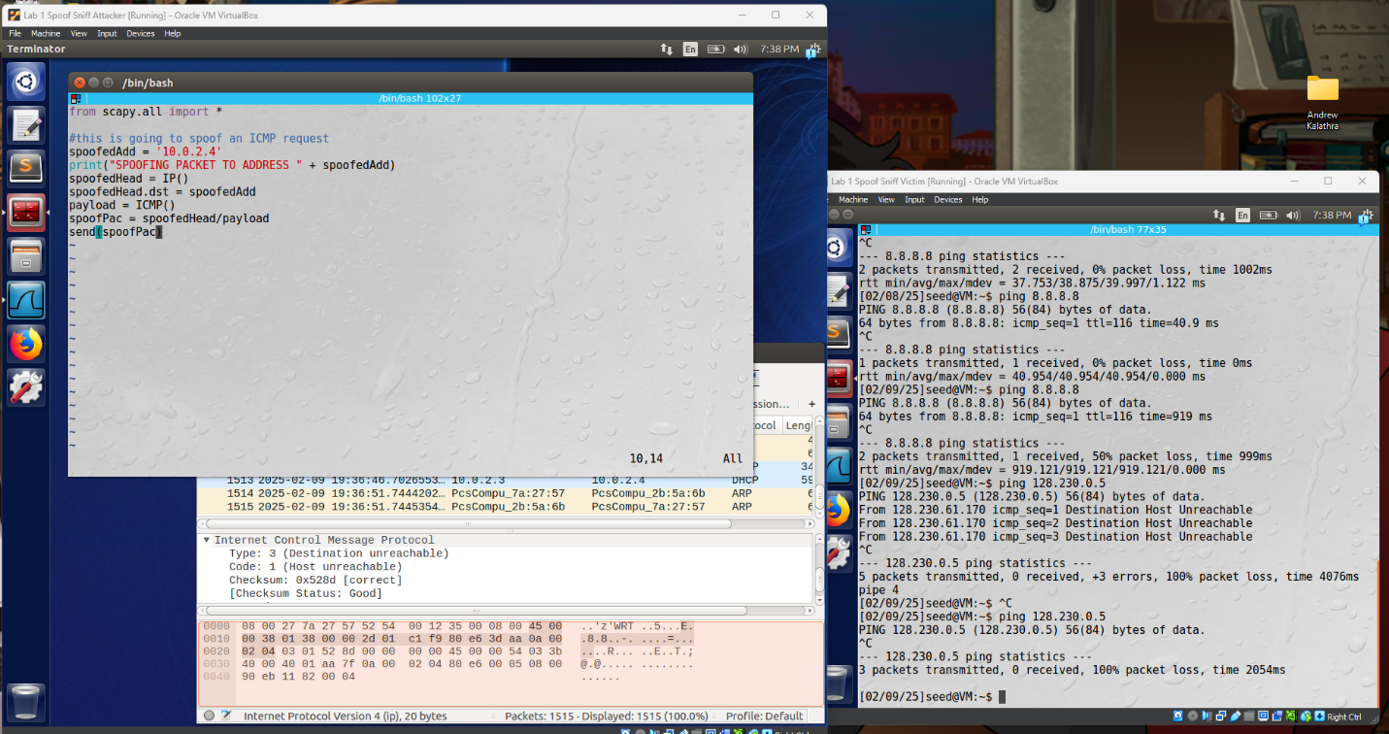
- As shown, the attacker code (left) makes an IP packet and an ICMP packet. The IP packet’s source address is not modified, but the destination address is modified to 10.0.2.4 (the victim). These two are combined and the packet is sent.
- 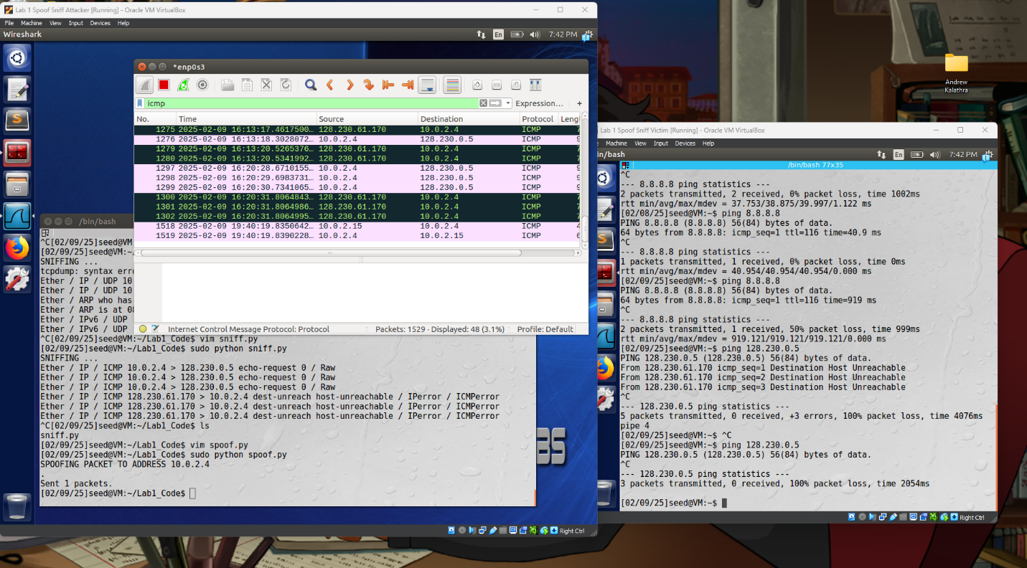
- Using Wireshark, we can tell that when the spoof.py code is run, an ICMP echo request is sent from the attacker (10.0.2.15) to the victim (10.0.2.4), which prompts an echo reply in the opposite direction.
- The real power of spoofing is in changing the source address, so I took it upon myself to modify this code to do such.
- 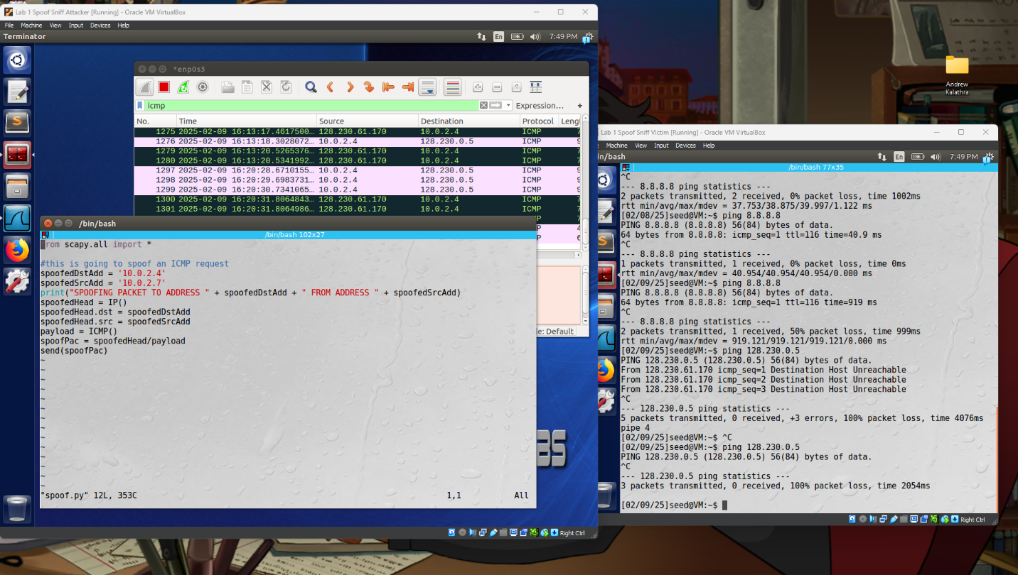
- This code has the slight modification of a new variable (spoofedSrcAdd), a longer string, and the source address being modified.
- 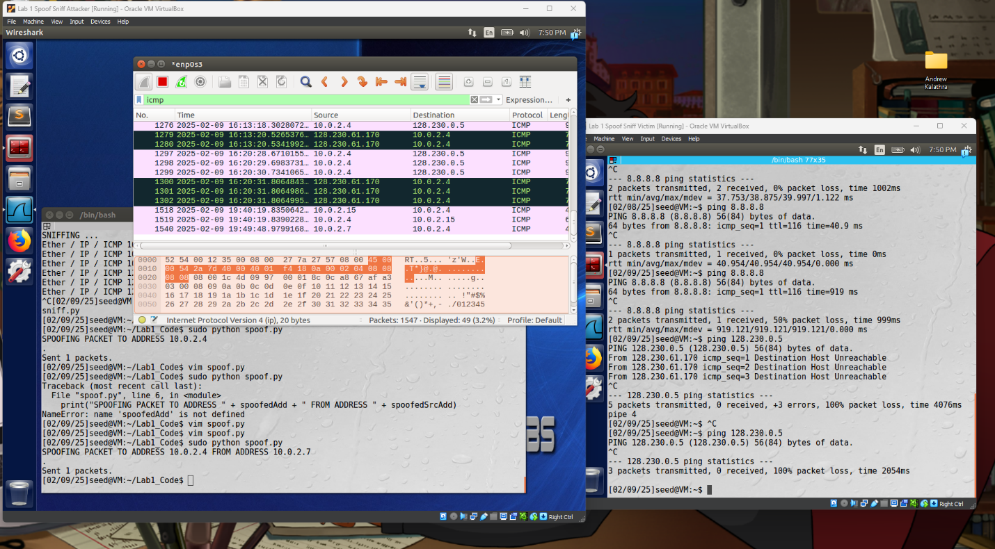
- As shown, when run on the attacker’s end, this generates a packet that is sent to the victim with a source address of 10.0.2.7 (an unknown address to the victim). Since this address is in the network, the victim does not send out a echo reply, but rather broadcasts to the network with a message (“Who has the IP address of 10.0.2.7?”). This has no reply as no device on the network has this IP address.

Task 4: Sniffing and-then Spoofing
- 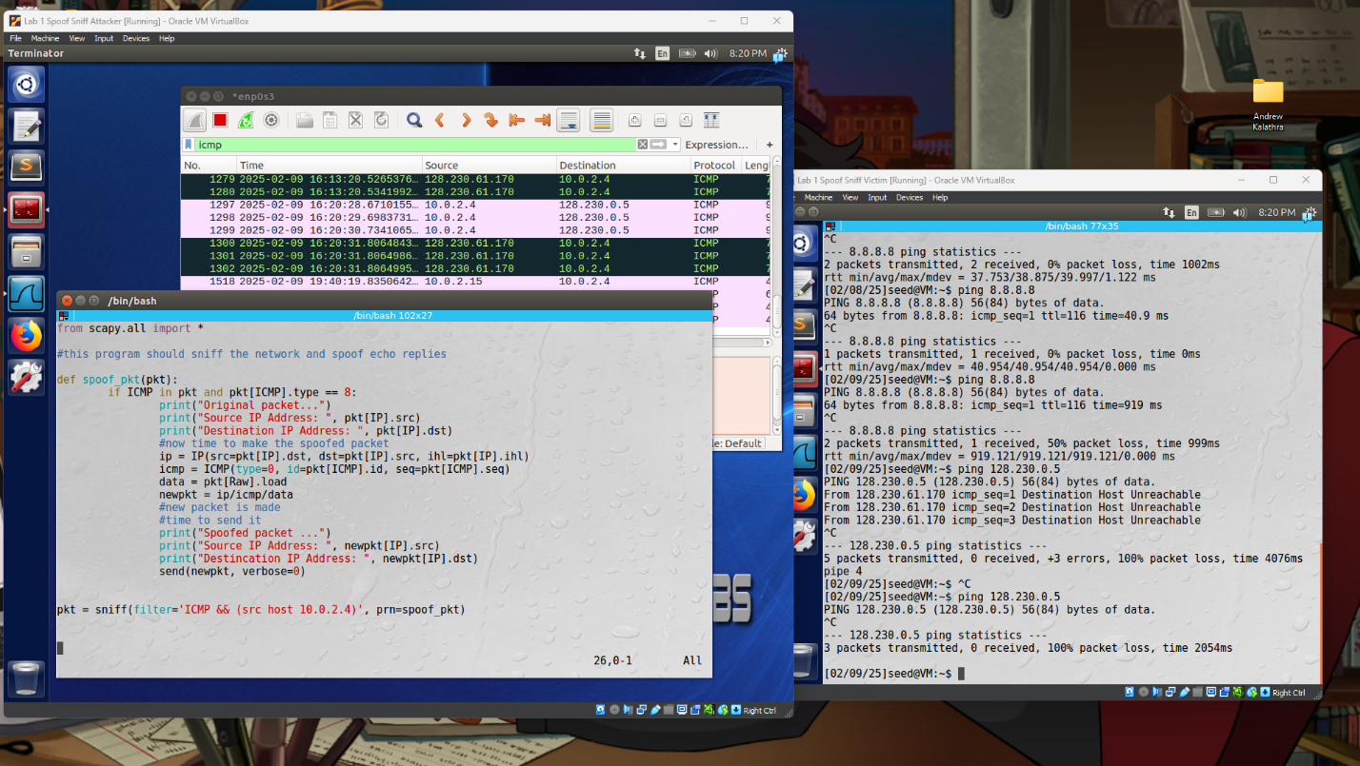
- As shown above, the code is pretty straight forward. When a packet is sniffed that is an ICMP packet and has a source address of 10.0.2.4, the spoof_pkt() method is run. In this method, the original information is printed out. Following this, a new packet is made, flipping the source and destination addresses for the IP packet, and keeping the ICMP packet essentially the same. The raw data is also added, and the full packet is assembled and sent. Finally, the new packet’s information is printed.
- 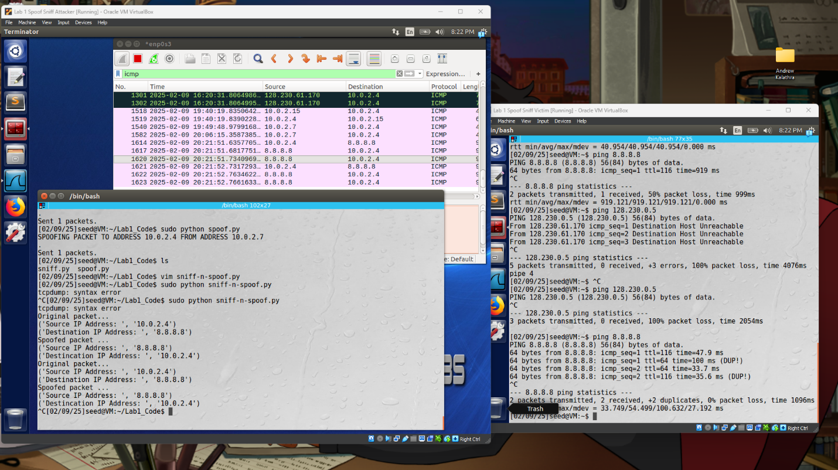
- When the victim ping’s 8.8.8.8, it gets back twice as many packets as it expects (as shown by Wireshark). This is a valid IP address that is outside the network, so a echo reply is sent back by 8.8.8.8. However, the attacker has also sniffed the network and spoof’s a packet back to the victim. This results in what is seen in Wireshark, where 1 echo request from 10.0.2.4 prompts 2 replies from 8.8.8.8.
- 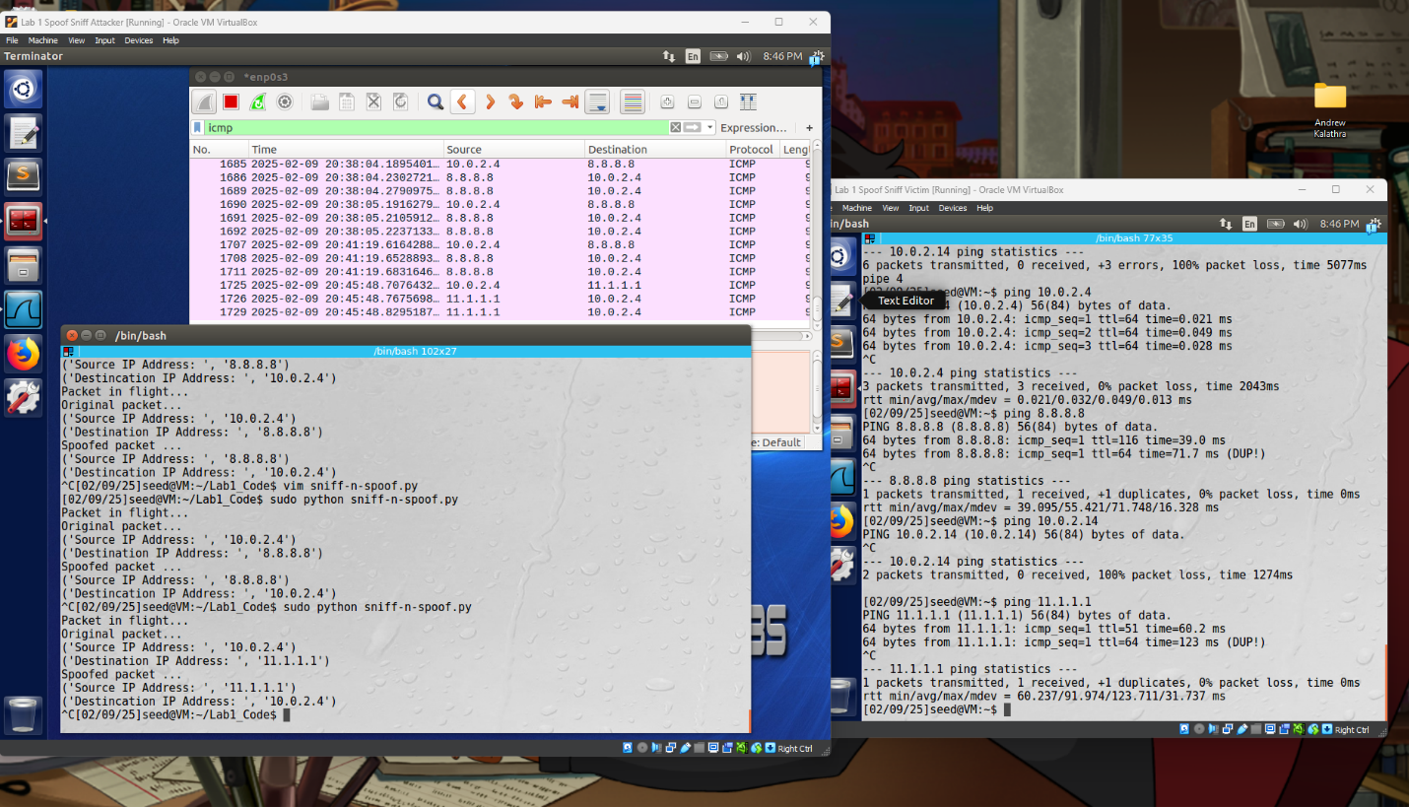
- When the address is outside the network but is not a machine that is on, the victim still gets a reply as if it is on. This is because the attacker picks up that the victim’s ping request is going from 10.0.2.4 (the victim) to 11.1.1.1 (a random IP address), so the attacker spoofs a echo reply back with a source address of 11.1.1.1. It can also be seen in this image that when the victim sends a packet to an address in the network (10.0.2.14), the attacker does not send a spoofed packet. This is because the packet that is sent by the victim is not an echo request since it is in the same network, but the victim does not know the MAC address of it. Due to this, it first broadcasts to the network, and if a reply is gained, then an echo request would follow. This, however, never happened, so the attacker never send a spoofed packet.

